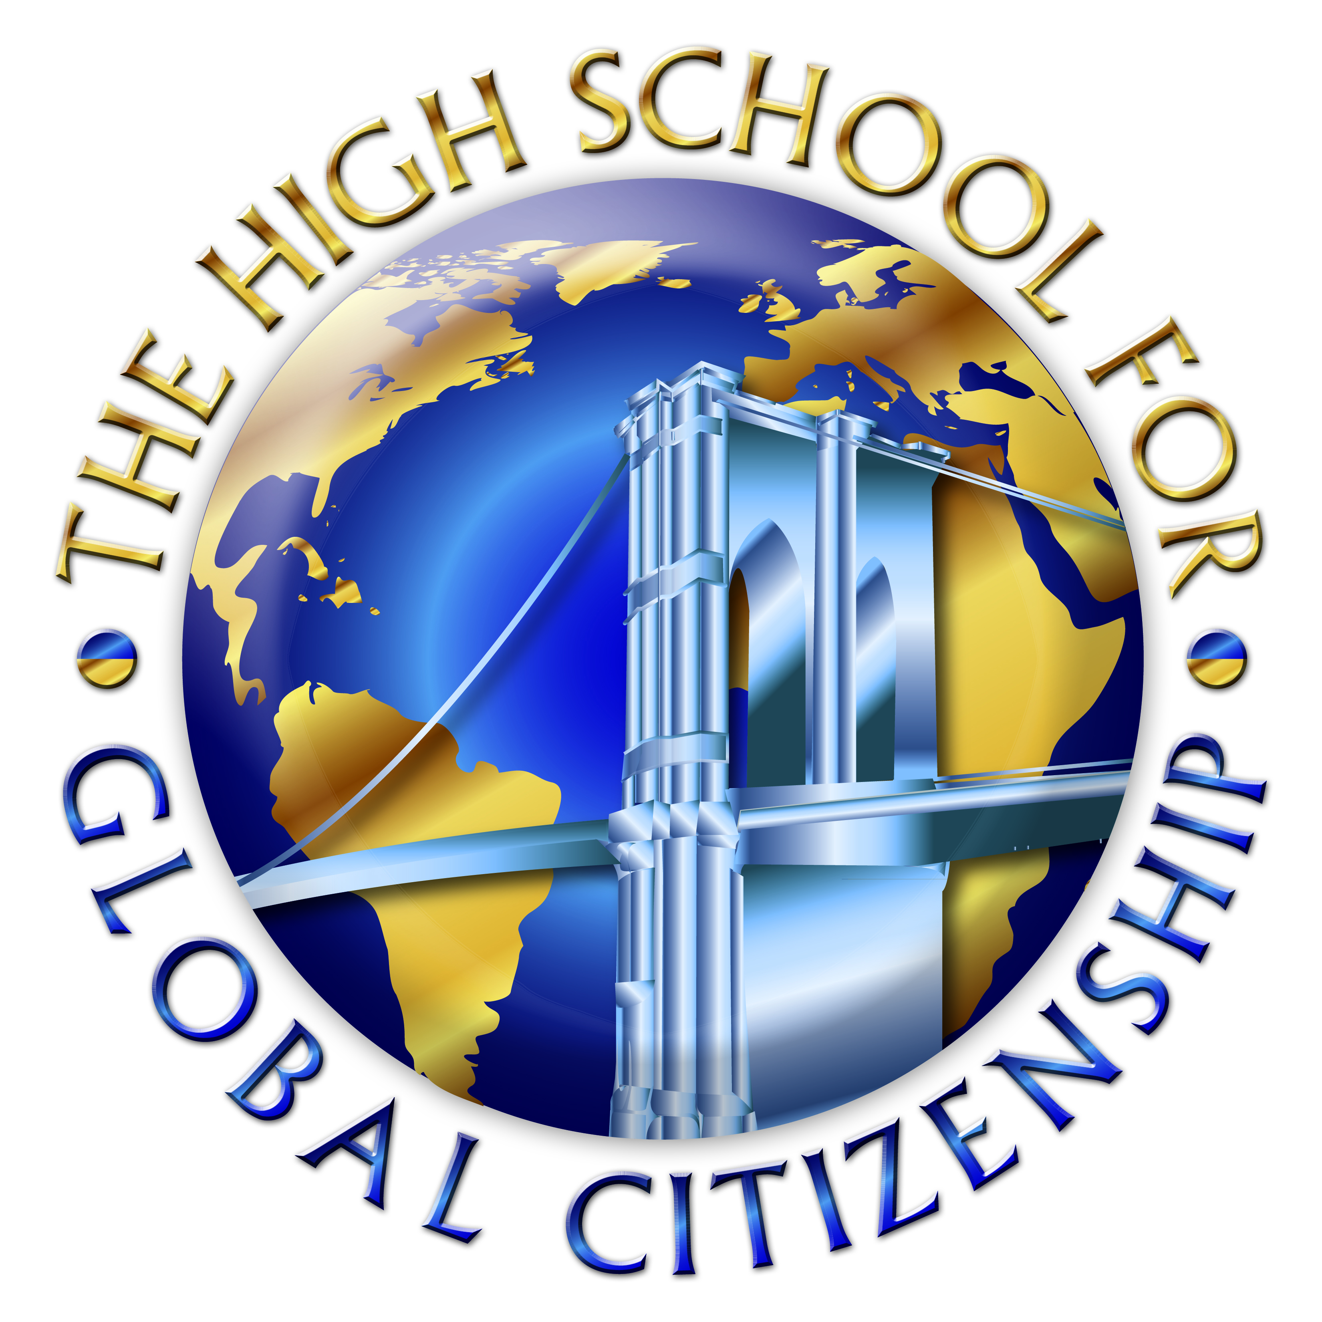
HIGH SCHOOL for Global Citizenship
at the Prospect Heights. Educational Campus
Michelle Rochon, Principal

Reciprocal Teaching for Reading

- SUMMARIZE  (I think...I bet...I think I’ll find out...I think I will learn...) | 2. ASK QUESTIONS  (Listen to the questions going through your head…What will…? How come…? Write them down)
3. CLARIFY  (List any unfamiliar words, relate to what you already know, answer any questions) | 4. PREDICT  (Anticipate what might come next. Write you're your predications)

VISUALIZE
Draw a picture depicting what the passage is about.

