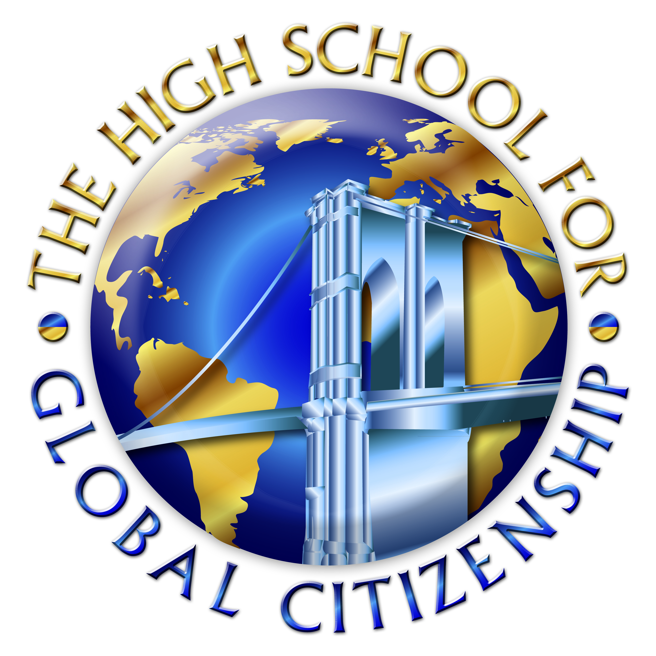
HIGH SCHOOL for Global Citizenship
at the Prospect Heights. Educational Campus
Michelle Rochon, Principal

Making a Commitment

What is one thing you need to do to get yourself to Well Developed?

When do you plan to do this?

What sort of support do you need?

