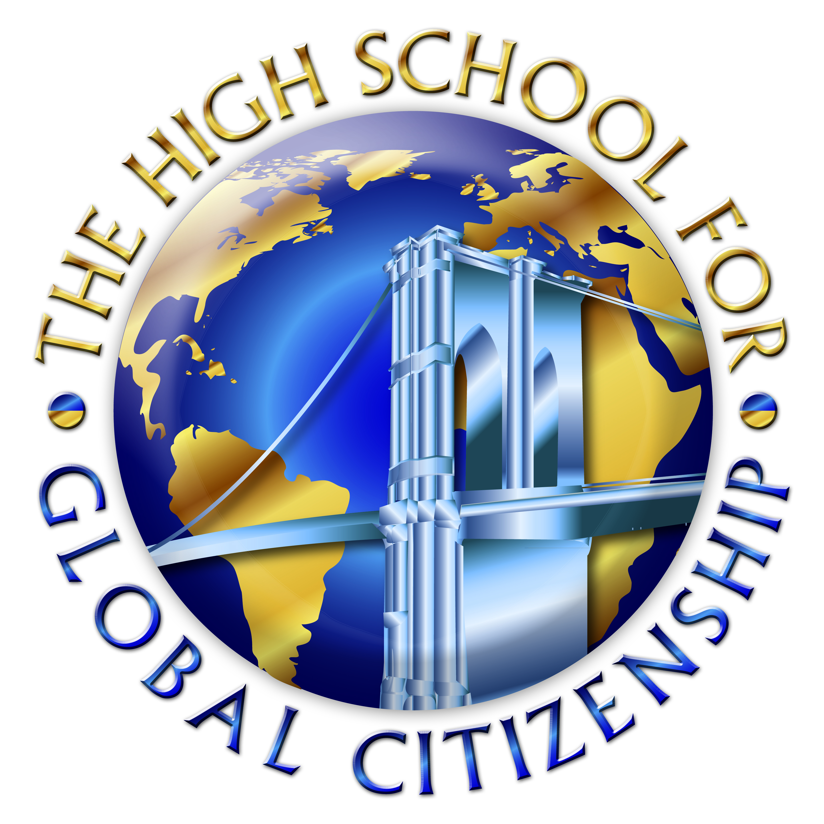
HIGH SCHOOL for Global Citizenship
at the Prospect Heights. Educational Campus
Michelle Rochon, Principal

Annotation Symbols

