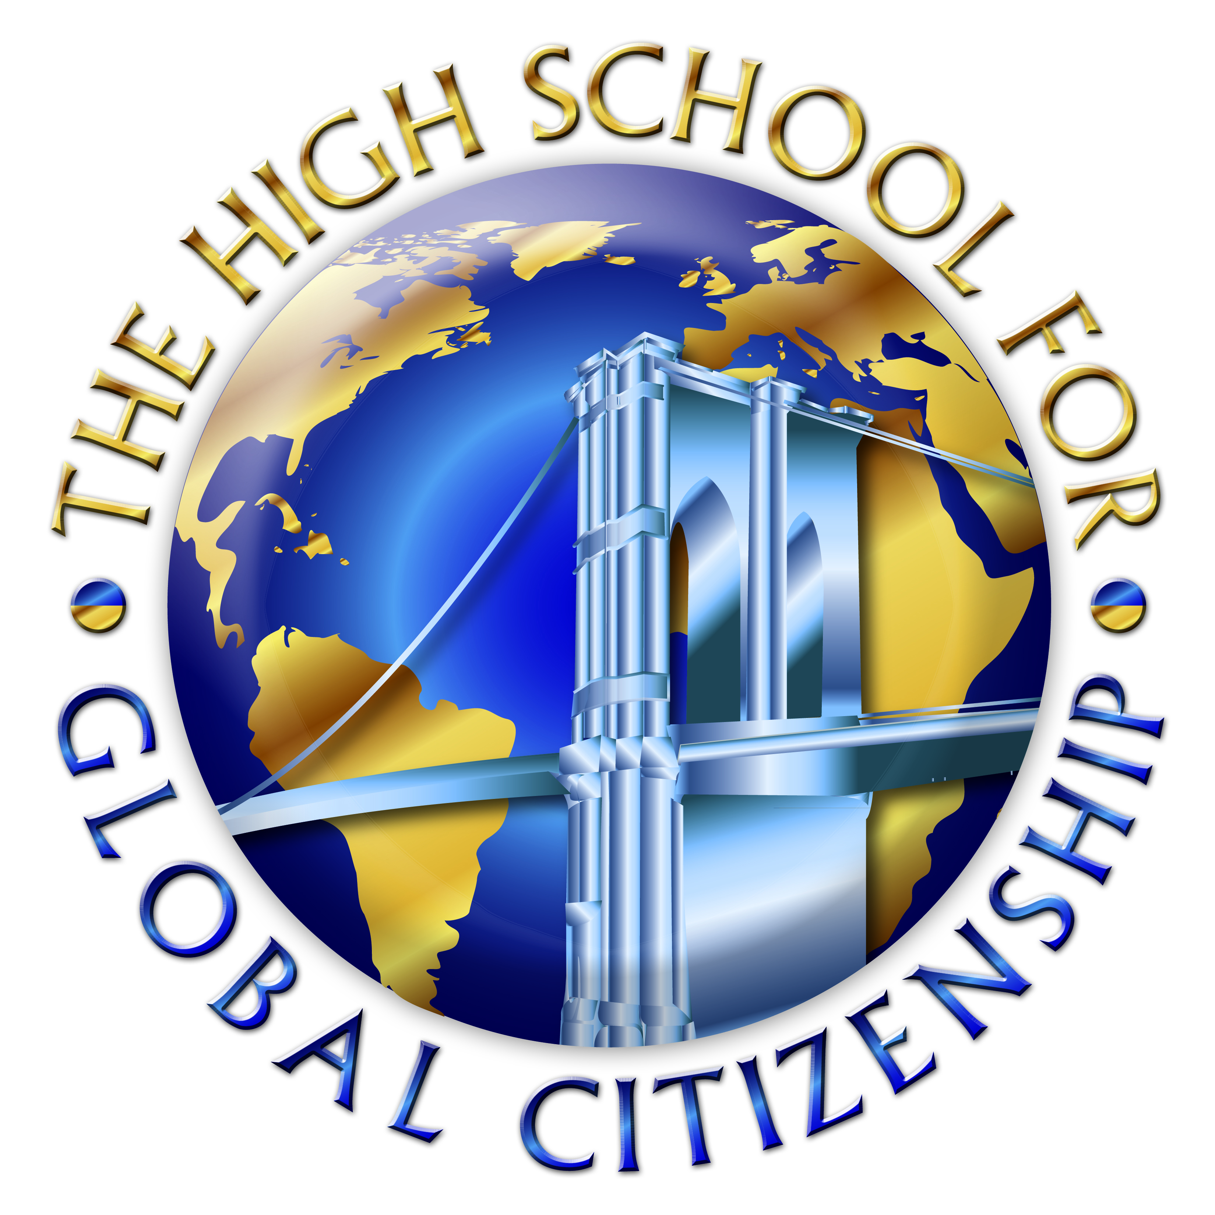
HIGH SCHOOL for Global Citizenship
at the Prospect Heights. Educational Campus
Michelle Rochon, Principal

3-2-1 Protocol for Gallery Walk

Quality Review Indicator 1.1: Curriculum
Ensure engaging, rigorous, and coherent curricula in all subjects, accessible for a variety of learners and aligned to Common Core Learning Standards and/or content standards

THREE Things I noticed while looking through this binder were…

1.

2.

3.

TWO Things that surprised me were….

1.

2.

One question/wondering I have is…

1.

HIGH SCHOOL for Global Citizenship
at the Prospect Heights. Educational Campus
Michelle Rochon, Principal

3-2-1 Protocol for Gallery Walk

Quality Review Indicator 1.2: Pedagogy
Develop teacher pedagogy from a coherent set of beliefs about how students learn best that is informed by the instructional shifts and Danielson Framework for Teaching, aligned to the curricula, engaging, and meets the needs of all learners so that all students produce meaningful work products

THREE Things I noticed while looking through this binder were…
1.

2.

3.

TWO Things that surprised me were….
1.

2.

One question/wondering I have is…
1.

HIGH SCHOOL for Global Citizenship
at the Prospect Heights. Educational Campus
Michelle Rochon, Principal

3-2-1 Protocol for Gallery Walk

Quality Review Indicator 2.2: Assessment
Align assessments to curricula, use on-going assessment and grading practices, and analyze information on student learning outcomes to adjust instructional decisions at the team and classroom levels

THREE Things I noticed while looking through this binder were…
1.

2.

3.

TWO Things that surprised me were….
1.

2.

One question/wondering I have is…

1.

HIGH SCHOOL for Global Citizenship
at the Prospect Heights. Educational Campus
Michelle Rochon, Principal

3-2-1 Protocol for Gallery Walk

Quality Review Indicator 3.4: High Expectations
Establish a culture for learning that communicates high expectations to staff, students, and families, and provide supports to achieve those expectations

THREE Things I noticed while looking through this binder were…
1.

2.

3.

TWO Things that surprised me were….
1.

2.

One question/wondering I have is…

1.

HIGH SCHOOL for Global Citizenship
at the Prospect Heights. Educational Campus
Michelle Rochon, Principal

3-2-1 Protocol for Gallery Walk

Quality Review Indicator 4.2: Professional Collaborations
Engage in structured professional collaborations on teams using an inquiry approach that promotes shared leadership and focuses on improved student learning

THREE Things I noticed while looking through this binder were…

1.

2.

3.

TWO Things that surprised me were….

1.

2.

One question/wondering I have is…

1.

